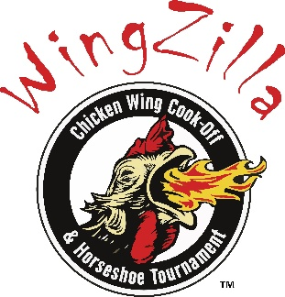

🍗 Chicken Wing Cook-Off Competitor Registration Form
📅 Saturday, September 6, 2025
📍 Service Credit Union Heritage Park, Berlin, NH

🔥 COMPETITION DETAILS
💵 Registration Fee: $50 per recipe
🏆 Prizes:
- 1st Place: $300 | 2nd Place: $200 | 3rd Place: $100

👤 CONTESTANT INFORMATION
Name: _____________________________________________
Business Name: _____________________________________
Address: ___________________________________________
City: ___________________ State: _______ Zip: _________
Phone: ____________________________________________
Email: _____________________________________________

🐔 RECIPE ENTRY
Number of Chicken Wing Recipes Submitted:
______ × $50 = Total Enclosed: $_________

⚠️ LIABILITY WAIVER
I hereby assume full responsibility for any personal injury or damage to personal property that may occur as a result of participating in the Chicken Wing Cook-Off. I release and hold harmless the Androscoggin Valley Chamber of Commerce, Service Credit Union Heritage Park, event staff, judges, and volunteers from any liability connected with this event.
Signature: ___________________________________
Date: _______________

📌 IMPORTANT RULES
- 🐔 Must prepare a minimum of 40 pounds of chicken wings
- 🍯 Recipes can be any style: sweet, spicy, savory, etc.
- ⏰ Wings must be ready to serve by 11:30 AM–12:00 PM at the latest
- 💵 Contestants may sell their wings at any price they choose
- 🚫 No other food items may be sold before 4:00 PM
- 🥤 You may sell soda and water only with your wings
- ✅ After 4:00 PM, contestants may sell anything they wish
- 🍻 NO ALCOHOL may be brought into the Park (NH State Liquor Commission regulation)
🚨 Offenders will be asked to remove alcoholic beverages or leave the event.

📬 RETURN COMPLETED FORM TO:
Androscoggin Valley Chamber of Commerce
961 Main Street, Berlin, NH 03570
📧 info@androscogginvalleychamber.com
📞 (603) 752-6060
👉 Deadline to register: ASAP – space is limited!

