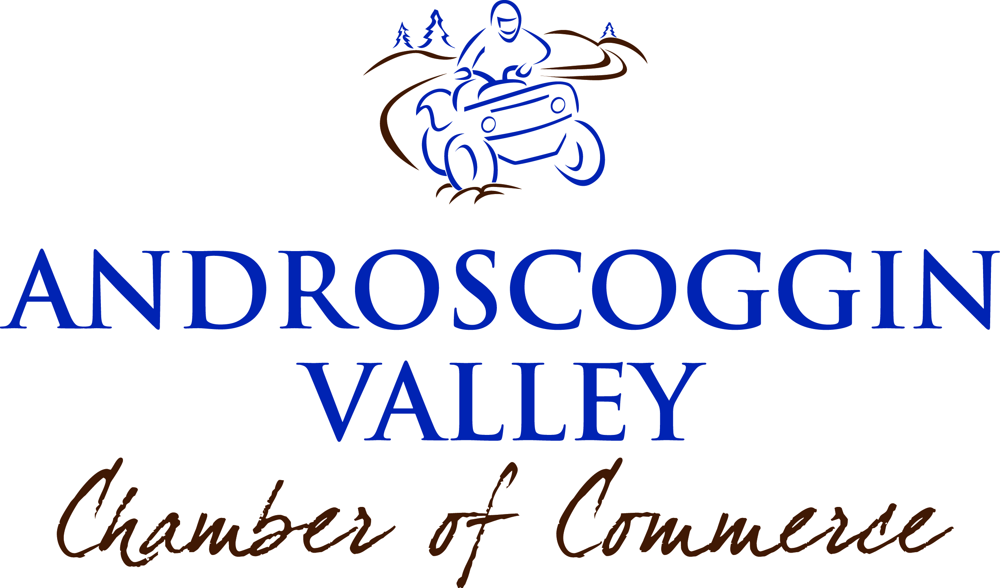

CHAMBER ANNUAL AUCTION 2015

The Androscoggin Valley Chamber of Commerce is gearing up for the 8th Annual Chamber Penny Sale/Silent Auction to be held on Saturday November 14, 2015 at the Northern Forest Heritage Park. This annual auction represents a major part of our operating budget and allows us to continue to do the great things we do! We need your help to meet our goal!

Your donation was greatly appreciated and we hope that you can meet or exceed last year’s generosity for this year’s auction!

Donors and items will be advertised in a local newspaper supplement and will be listed on the Auction Program, providing excellent advertisement and public relations to you! To assure your listing in the Chamber Auction insert, your donation MUST be listed with us by Wednesday, October 28th. Anything received after this date may not be included in the ad.

Any item with a retail value of $200.00 or more will receive SPOTLIGHT recognition, and any item worth $1,000 or more will receive BIG-TICKET recognition.

Please complete and return the form below by Wednesday October 28, 2015 indicating what you will be donating to this year’s Androscoggin Valley Chamber of Commerce Auction. Forms can be dropped off, mailed or faxed. Items can be dropped off at our office located at 961 Main Street, Berlin (Brown Company House) between the hours of 8:30am to 4:30pm, or you can request a pick-up.
--------------------------------------------------------------------------------------------------------------

Name:_________________________________Company:________________________________

Company Name:_________________________________________________________________

Mailing Adress:__________________________________________________________________

Telephone Numbers:_________________________Fax Number:__________________________

E-Mail:____________________________________Website Address:_______________________

DONATION (S)

_____________________________________________Retail Value:_______________

_____________________________________________Retail Value:_______________

